Nama : Riris Agriela Savitri

NIM : L200170029

Kelas : A

UAS

No.1

*Membuat topologi jaringan sebagai berikut:*

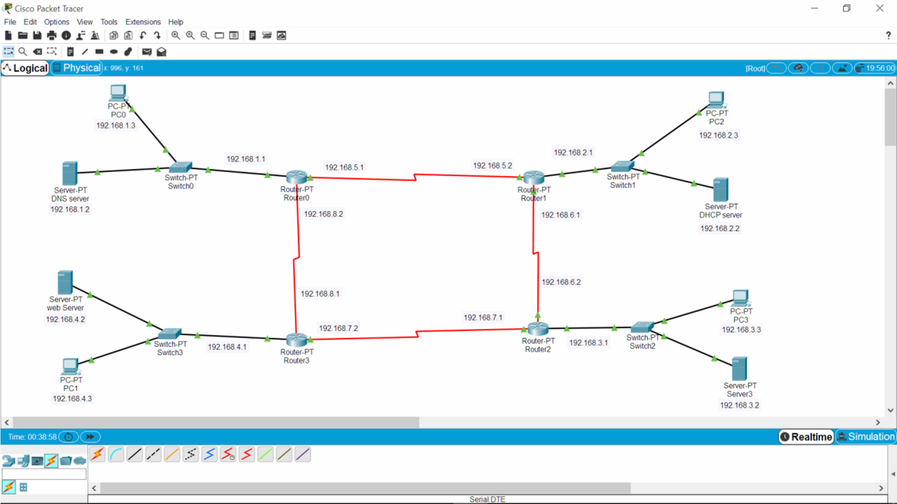

No.2

*Konfigursi pengalamatan ip(sesuai gambar diatas(no.1))*

a)

|  |  |  |
| --- | --- | --- |
| Router 0 | Server DNS | PC 0 |
| SE 2/0 (ip add 192.168.5.1) | Ip add 192.168.1.2 | Ip add 192.168.1.3 |
| SE 3/0 (ip add 192.168.8.2) |
| Fa 0/0 (ip add 192.168.1.1) |

b)

|  |  |  |
| --- | --- | --- |
| Router 1 | Server DHCP | PC 2 |
| SE 2/0 (ip add 192.168.6.1) | Ip add 192.168.2.2 | Otomatis sesuai pengaturan dhcp yang dibuat  (ip add 192.168.2.3) |
| SE 3/0 (ip add 192.168.5.2) |
| Fa 0/0 (ip add 192.168.2.1) |

c)

|  |  |  |
| --- | --- | --- |
| Router 2 | Server3 | PC 3 |
| SE 2/0 (ip add 192.168.7.1) | Ip add 192.168.3.2 | Ip add 192.168.3.3 |
| SE 3/0 (ip add 192.168.6.2) |
| Fa 0/0 (ip add 192.168.3.1) |

d)

|  |  |  |
| --- | --- | --- |
| Router 3 | Server Web | PC 1 |
| SE 2/0 (ip add 192.168.8.1) | Ip add 192.168.4.2 | Ip add 192.168.4.3 |
| SE 3/0 (ip add 192.168.7.2) |
| Fa 0/0 (ip add 192.168.4.1) |

*Test no.2*

* DNS server

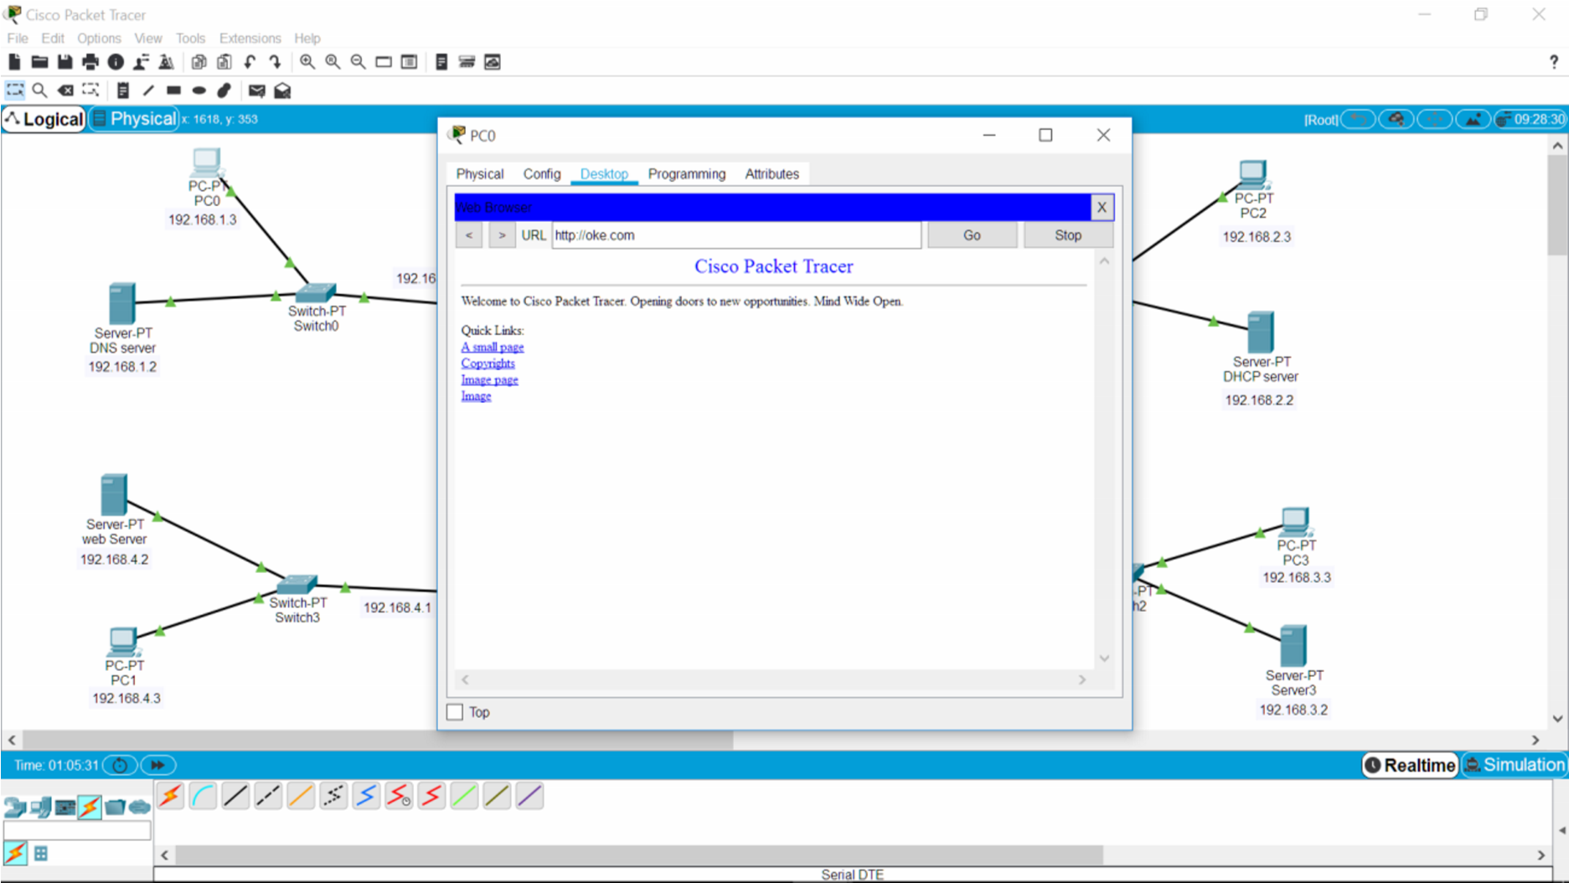

* DHCP Server

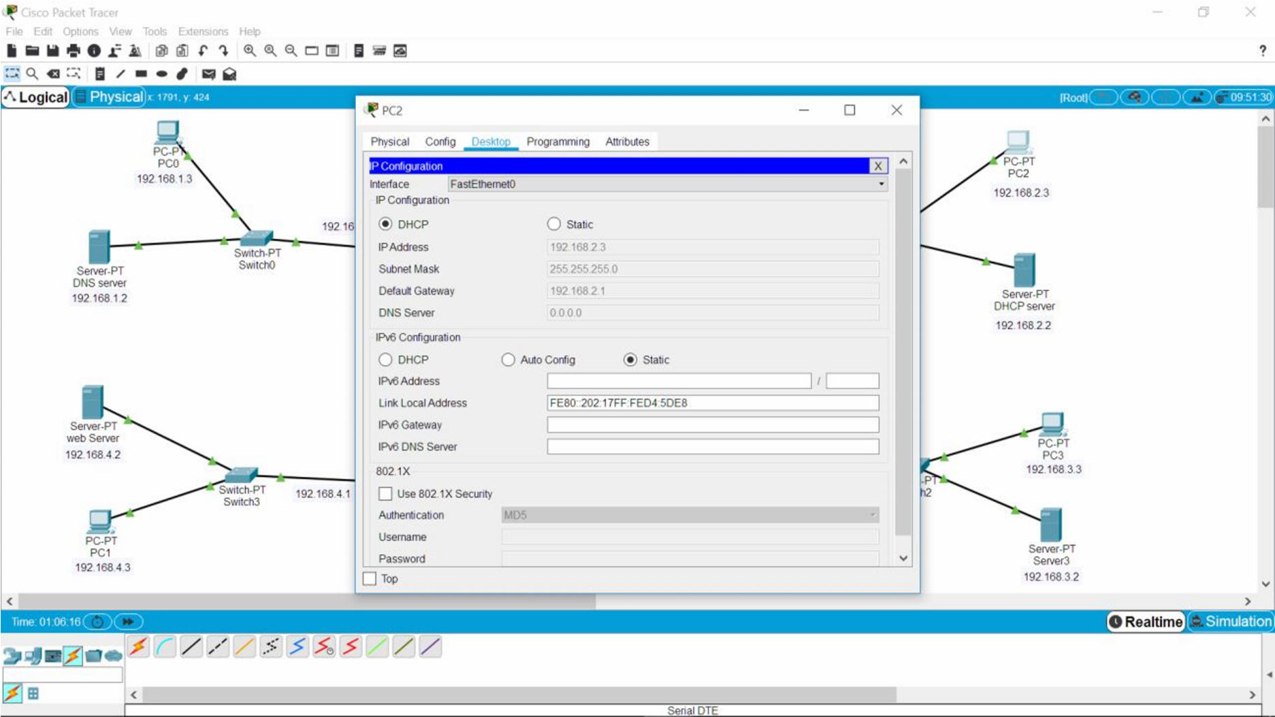

* Server3

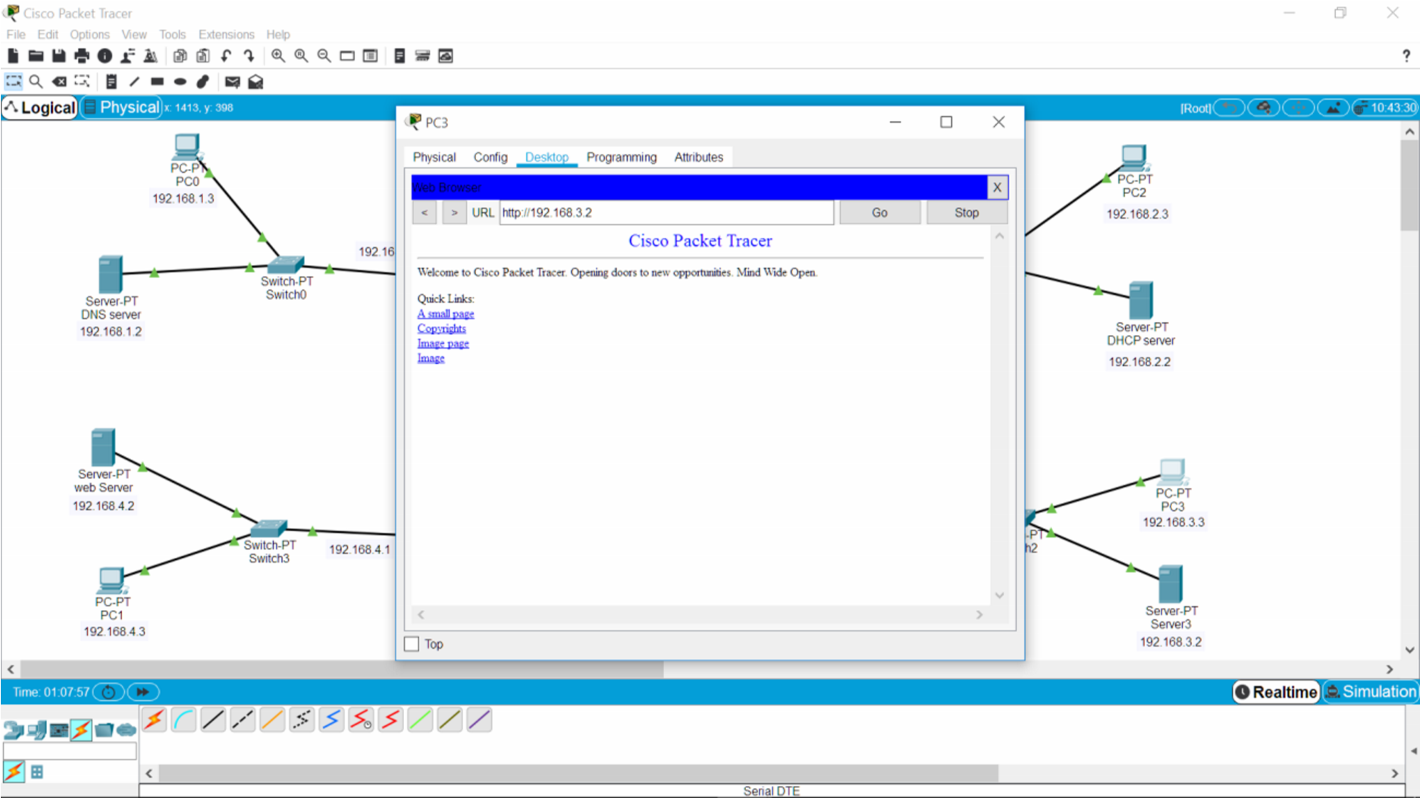

* Server Web

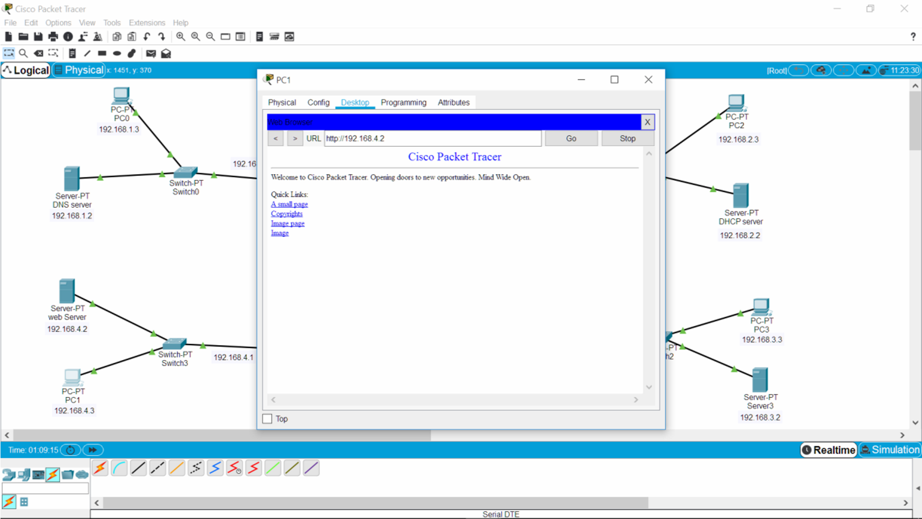

No.3

Konfigurasi routing dinamis

a) Router 0

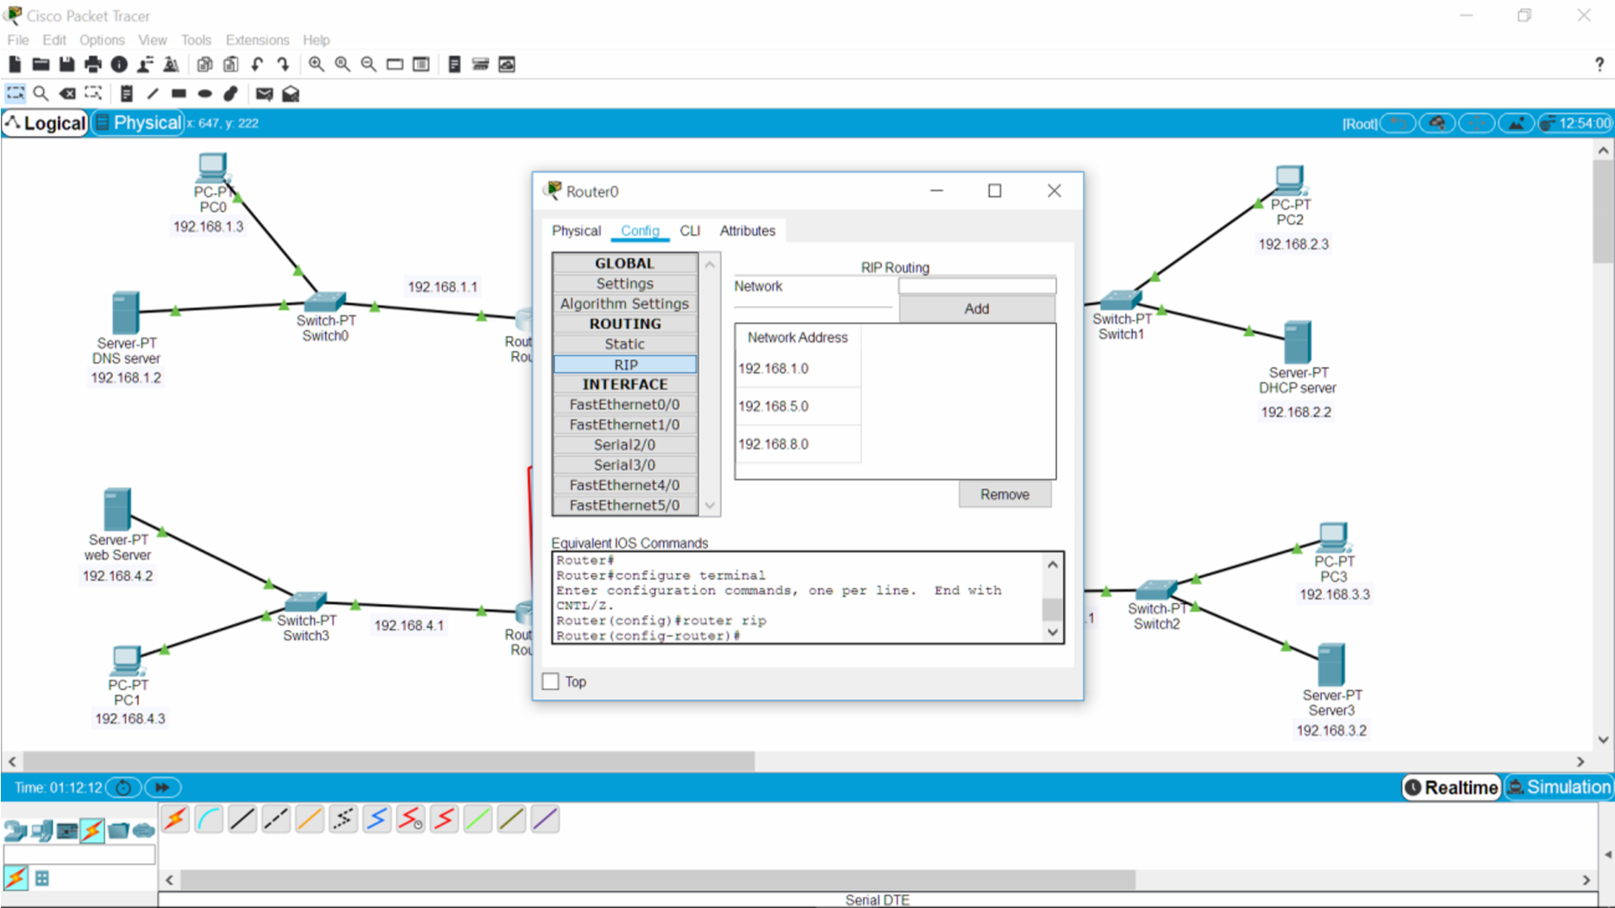

b) Router 1

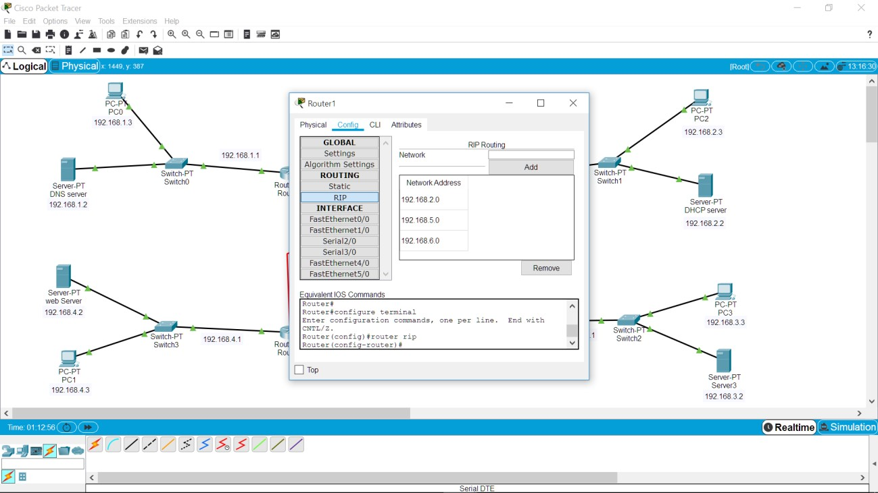

c) Router 2

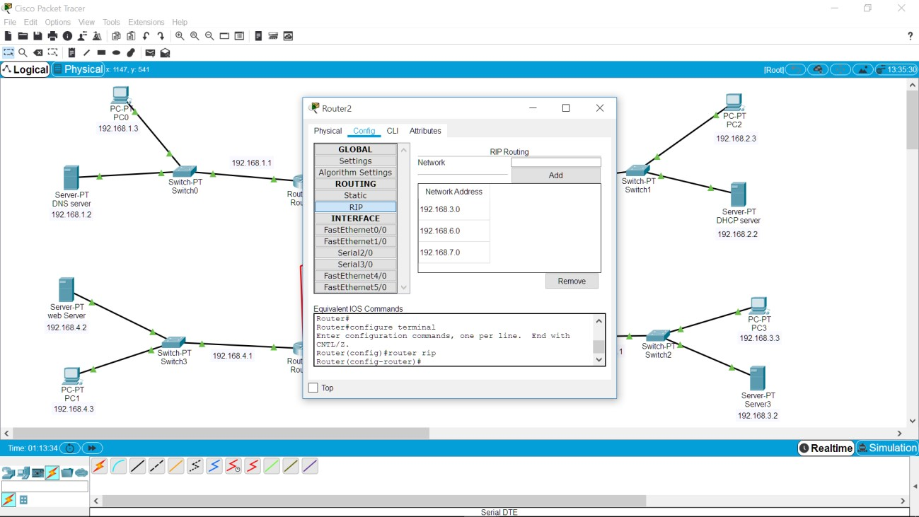

d) Router 3

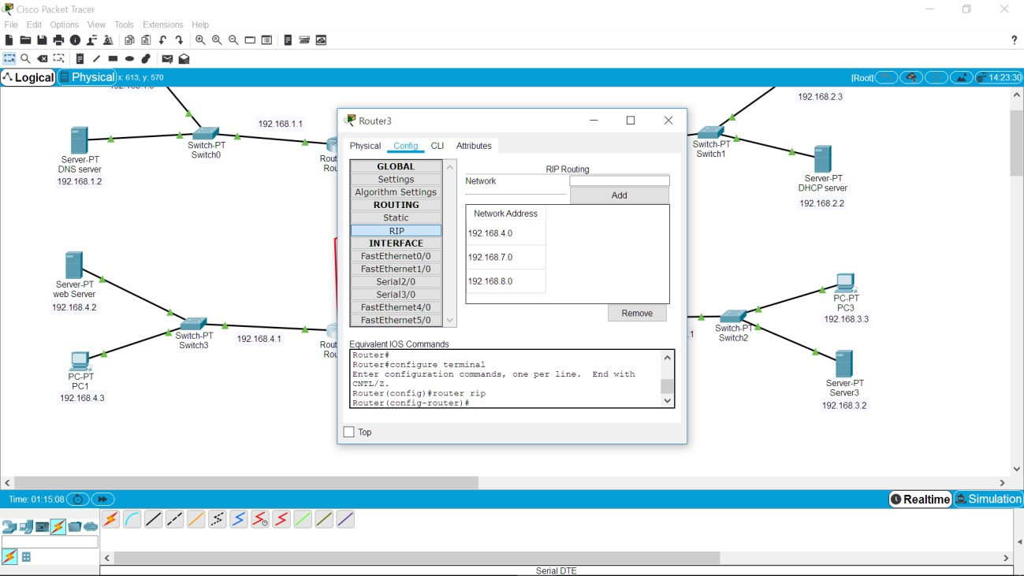

* *Test no.3 router dinamis (uji konektivitas antar PC)*

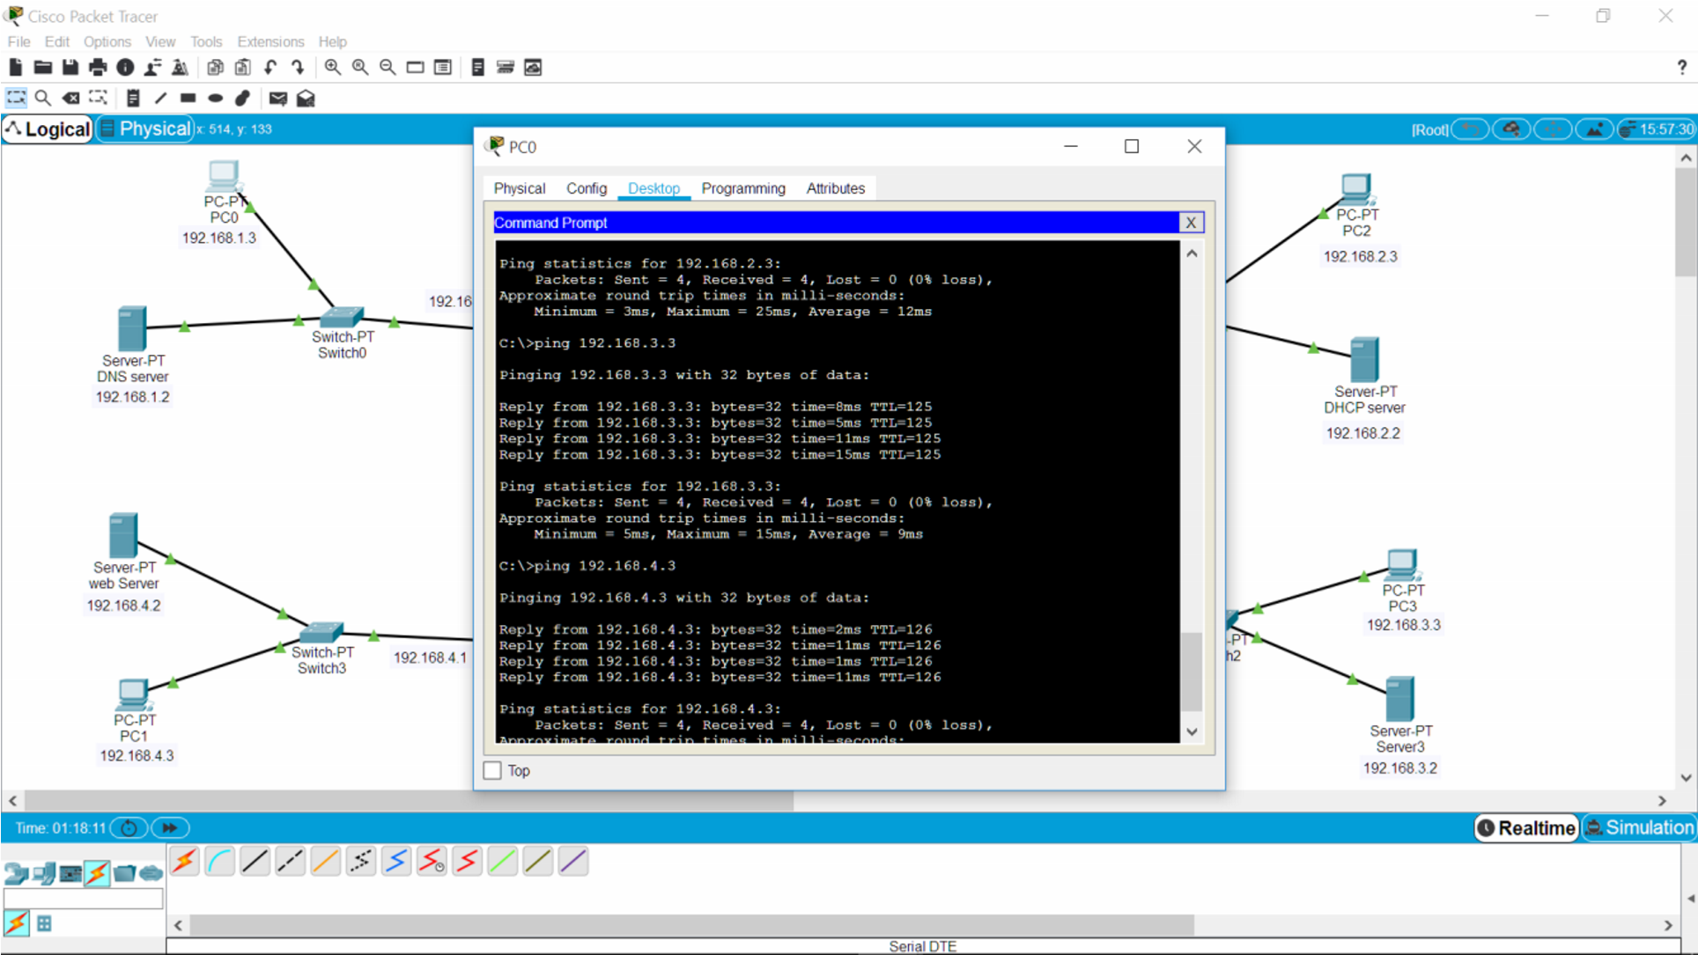

* *Test no.3 router dinamis (uji konektivitas PC ke server antar router)*

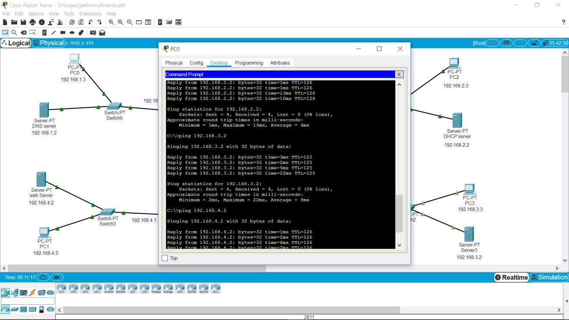

No.4

*Konfigurasi router statis*

1. Router 0

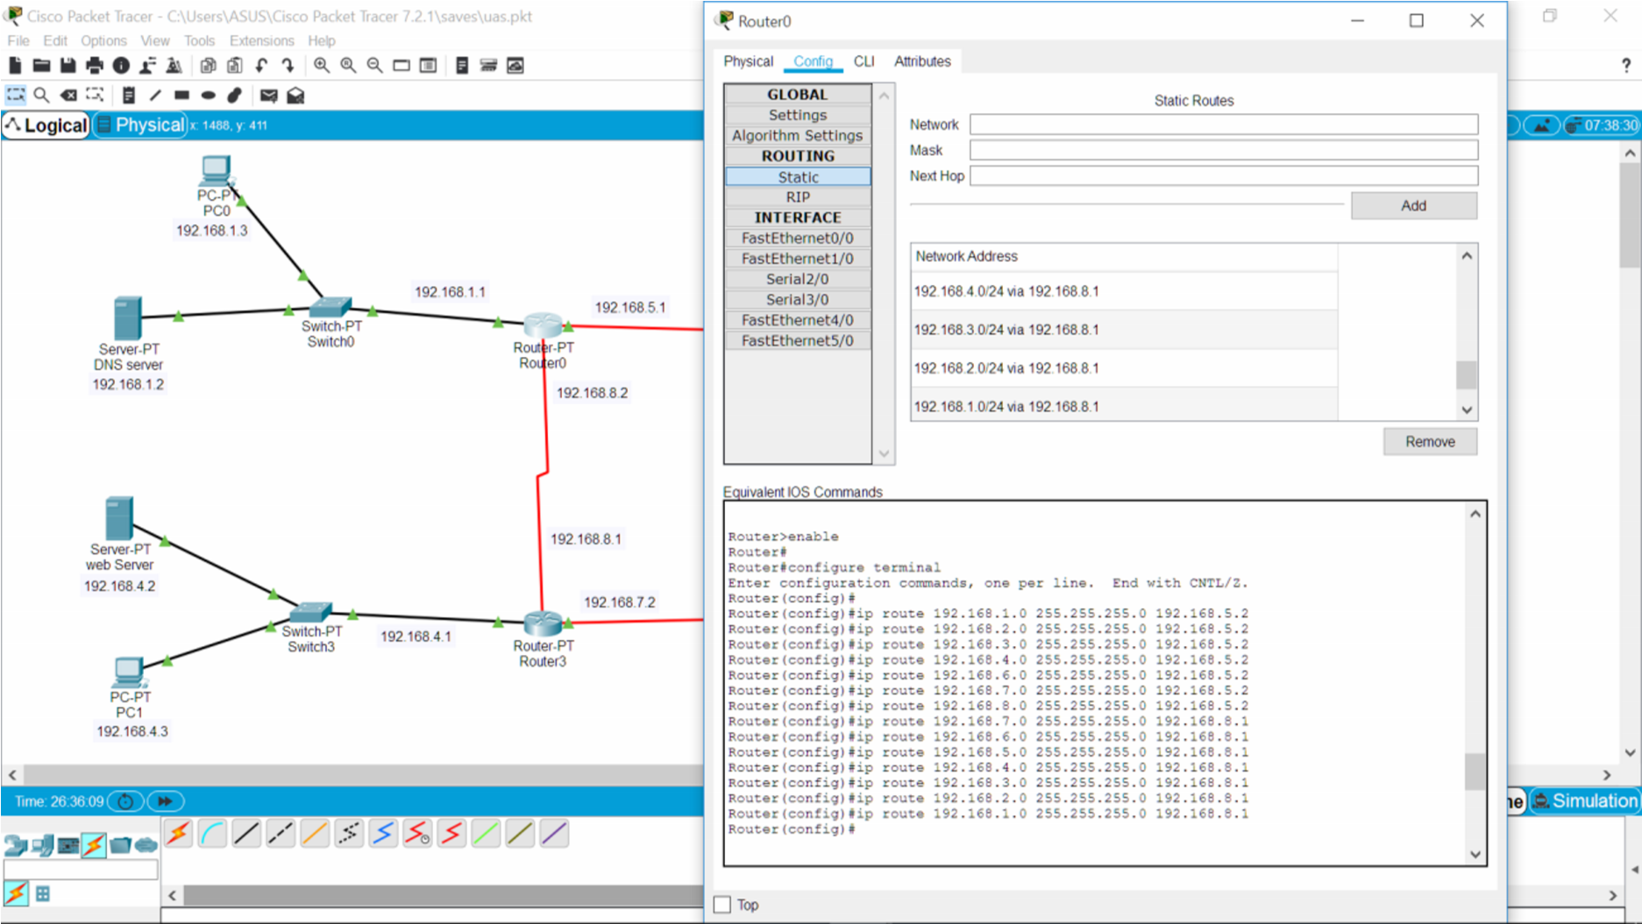

1. Router 1

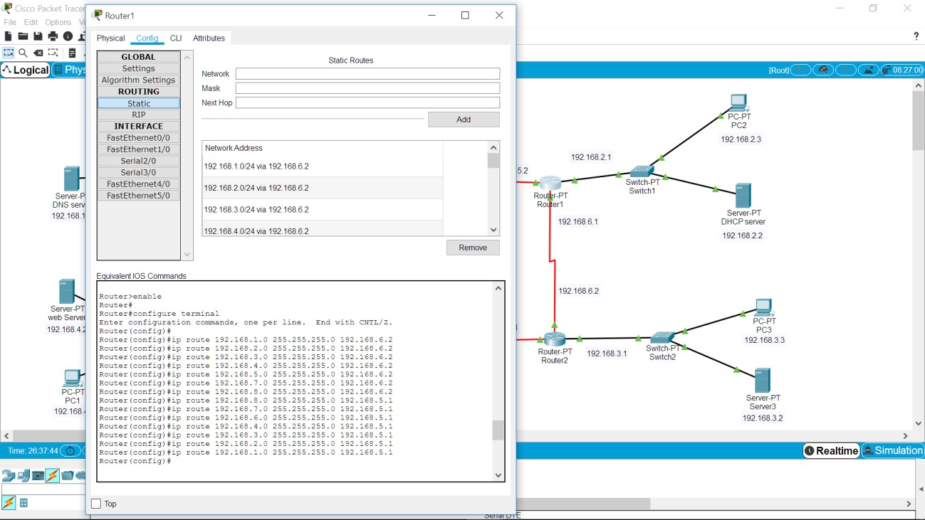

1. Router 2

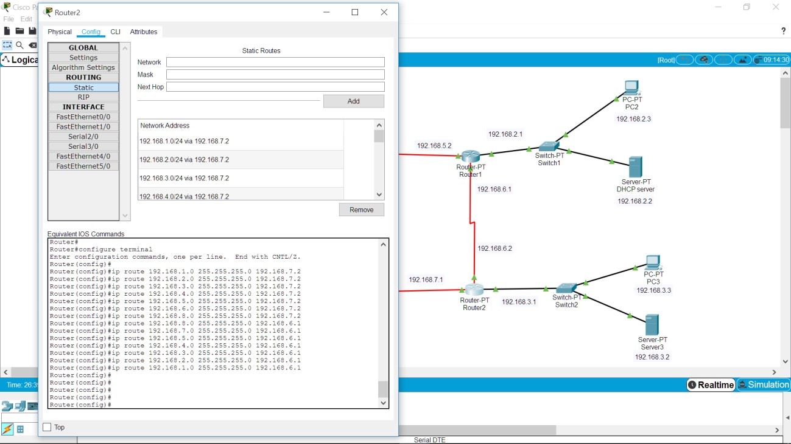

1. Router 3

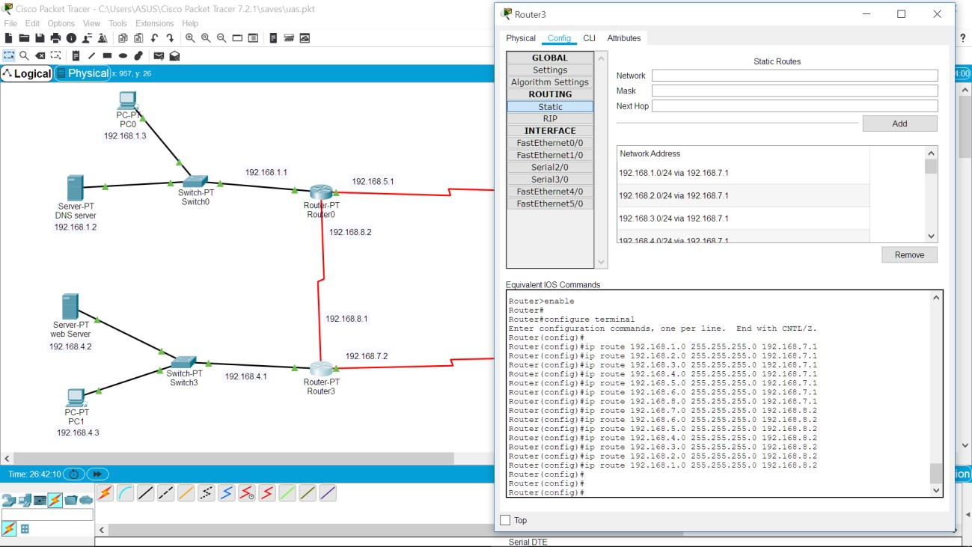

* *Test no.4 router statis(uji konektivitas antar PC)*

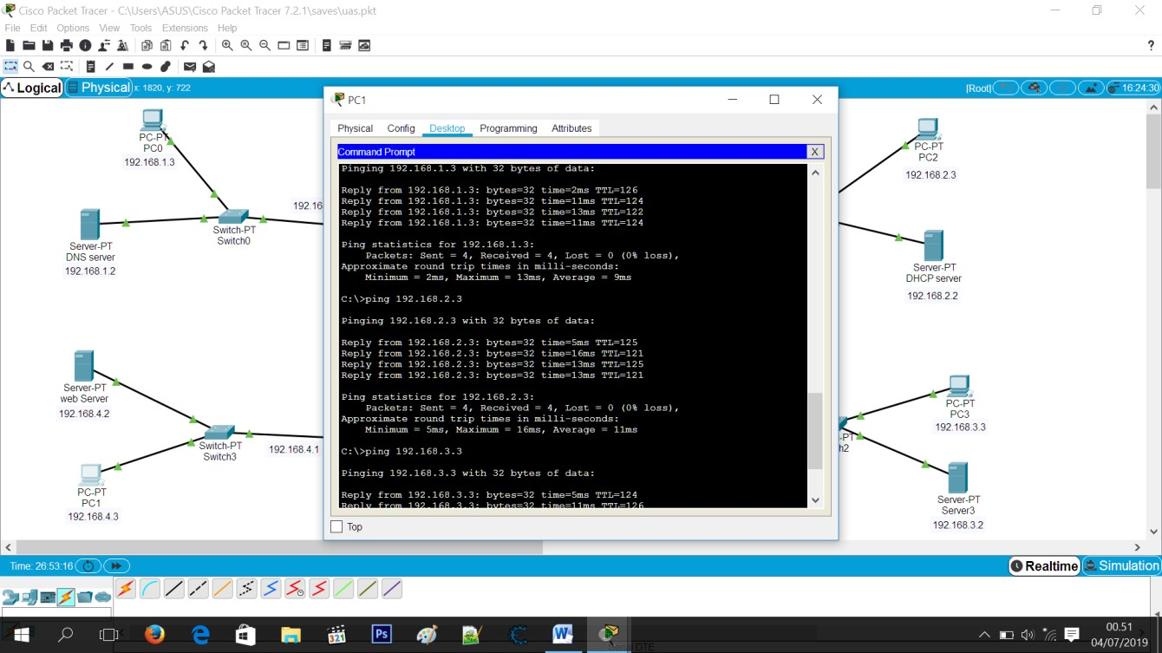

* *Test no.4 router statis (uji konektivitas PC ke server antar router)*

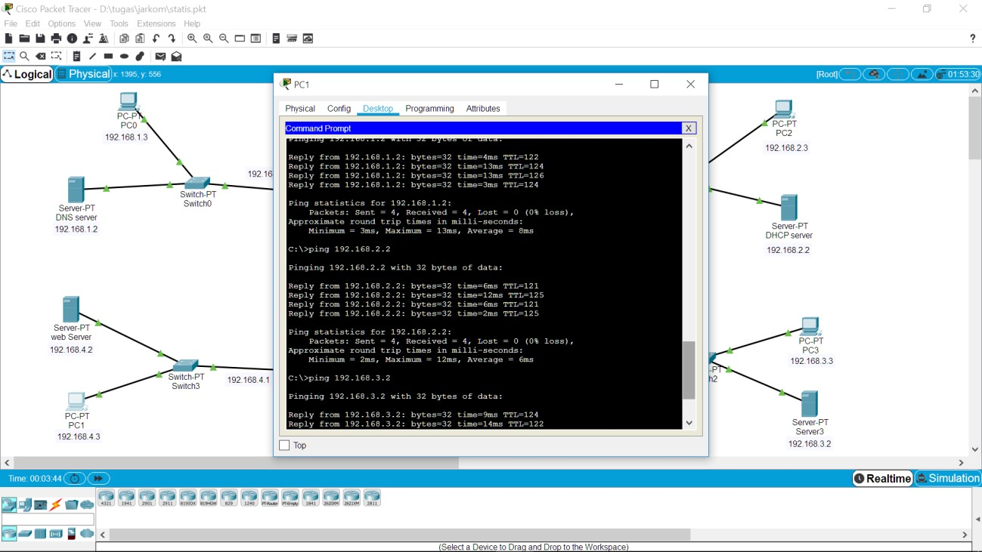

No.5

*Menggunkan access list untuk membatasi 1 PC saja yang dapat mengakses server web*

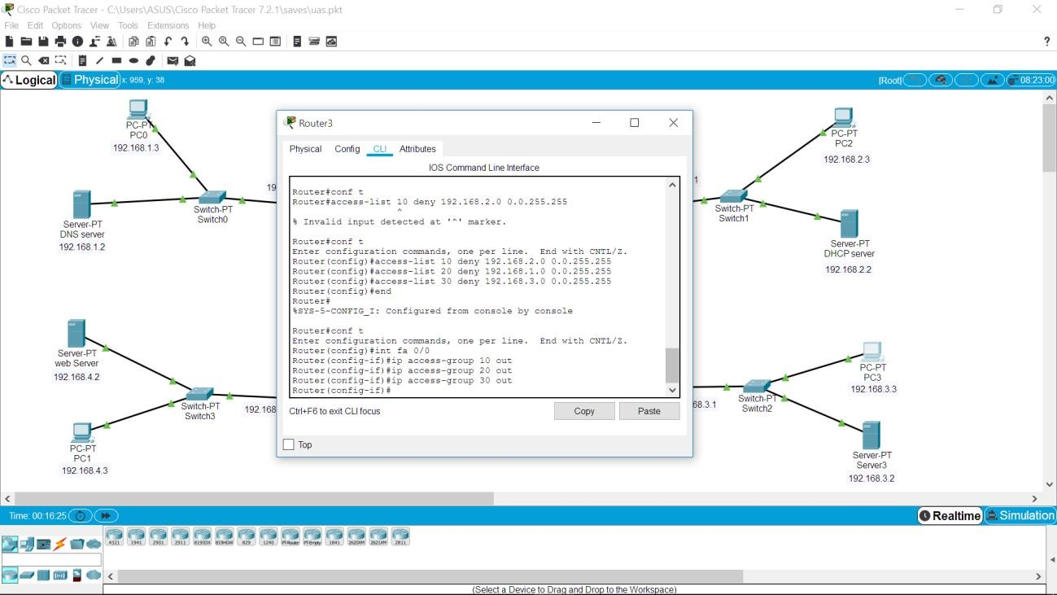

1. Test akses dengan PC 0

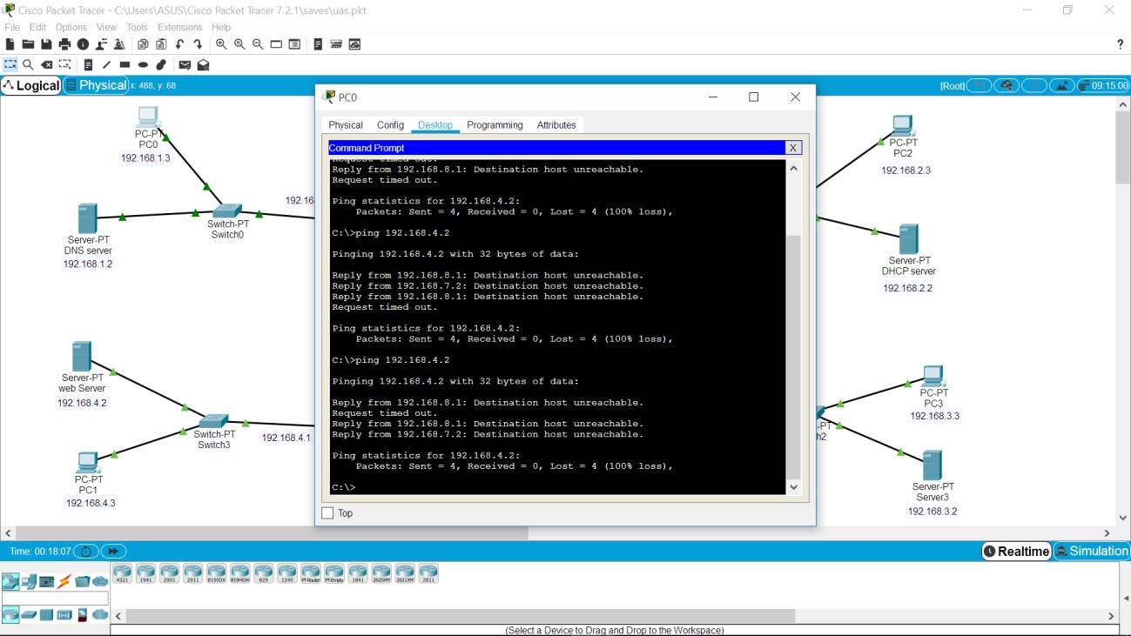

1. Test akses dengan PC 2

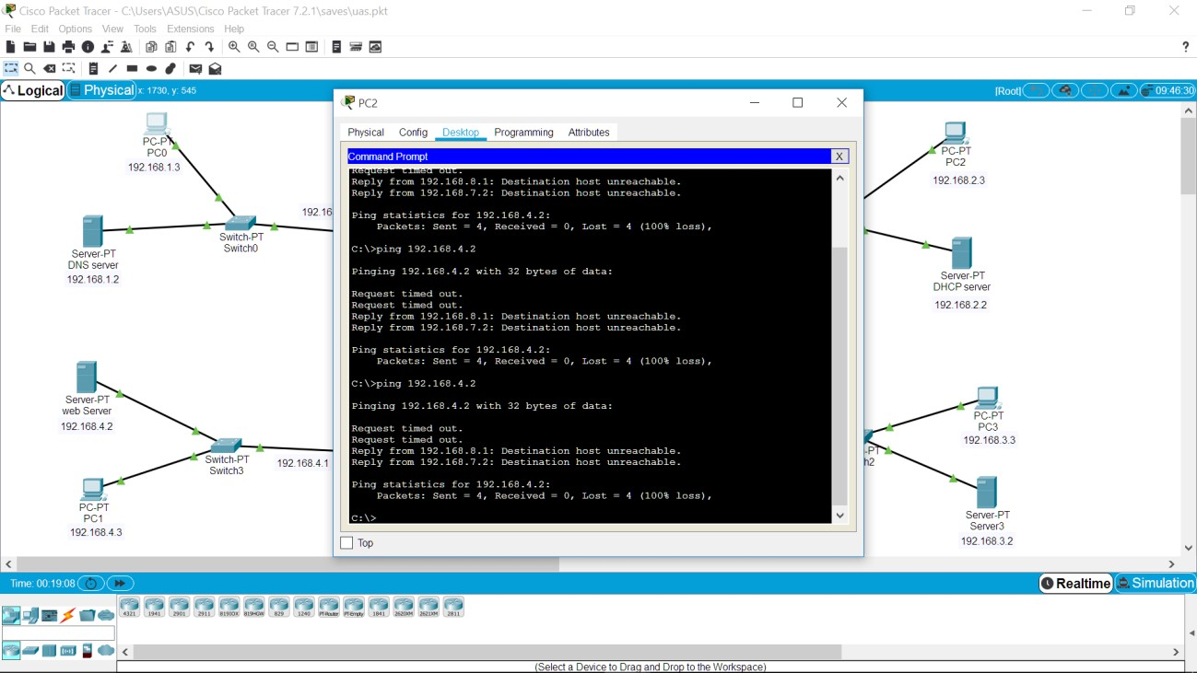

1. Test akses dengan PC 3

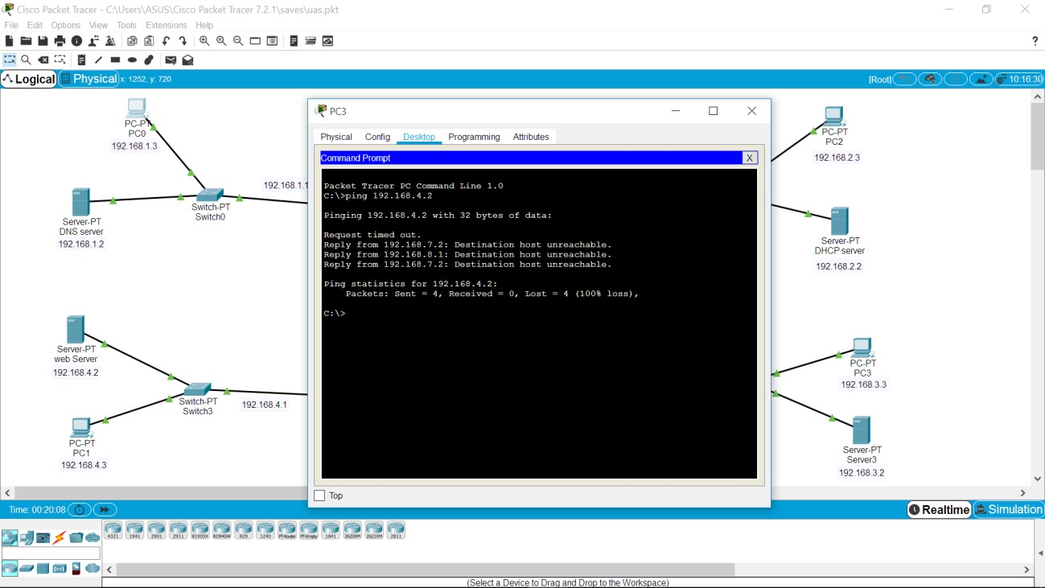

1. Test akses dengan PC 1

